**UOG, Tokyo University test a virus on Guam’s rhino beetles**

A team of scientists and students from the University of Guam (UOG), the Tokyo University of Agriculture & Technology (TUAT) and Palau Community College (PCC) are collaborating on lab experiments to discover if a virus which was introduced to control coconut rhinoceros beetles in Palau can be used to control rhino beetles on Guam. The research team consists of Dr. Aubrey Moore, Christian Cayanan, Laura Caser, Leahmarie Bukurou and Raimunt Mesubed at UOG, Dr. Madoka Nakai and Mayuho Yamauchi at TUAT, and Dr. Christopher Kitalong at PCC.

The coconut rhinoceros beetle (CRB), first found on Guam in 2007, has been in Palau for a long time. During the 1950s about 50% of Palau’s coconut palms were killed by a severe CRB outbreak. During the 1960s, a virus which infects only rhino beetles was discovered and released in Palau and on many other Pacific islands which had been invaded by CRB. Wherever the virus was released, CRB populations and resulting damage were reduced to very low levels. In addition, the virus is self-sustaining in the CRB population.

A few years after CRB was detected on Guam, the rhino beetle virus was released on Guam with the expectation that this would stop the outbreak. Unexpectedly, nothing happened. It was later discovered that the Guam CRB population is genetically different from other CRB populations and lab tests show that this genotype, referred to as CRB-G, is apparently resistant to the rhino beetle virus. Since CRB-G invaded Guam in 2007, it has also invaded Palau, Papua New Guinea, Solomon Islands, Hawaii (Oahu), and the Northern Mariana Islands (Rota). Outbreaks on these islands are causing major damage to coconut palms and oil palms. A Pacific-wide effort is underway to find new isolates of the rhino beetle virus which will infect CRB-G and can be used to control these populations.

“We’re trying all kinds of different strains of the virus hoping to find one that matches our beetle,” Moore said. “The one we’re testing [now] is from Palau. It doesn’t seem to kill our beetles, but we’re wondering if there are some sublethal effects. That would be really important. You don’t have to kill an insect to control it. If you can stop it from feeding or flying or reproducing, that will reduce its damage.”

Funding from a U.S. Forest Service grant and a Department of the Interior Office of Insular Affairs grant as well as a new student exchange agreement signed this year between the UOG College of Natural & Applied Sciences and TUAT are supporting the current collaborative research.

As the first exchange student of the new partnership, Mayuho Yamauchi, who will soon begin a Ph.D. program specific to the coconut rhinoceros beetle at TUAT, spent this past March in Guam designing lab experiments with Moore and collecting data. Her advisor is Dr. Madoka Nakai, an insect virologist who has been visiting Guam and working with UOG for the past 10 years to find a biological control agent for the CRB population on Guam.

The experiment involved feeding banana mash with the virus added to a group of CRB-G adults and feeding banana mash without virus to an experimental control group. Each beetle is observed daily to record mortality, food consumption, flight activity, and reproduction rates. Each beetle was uniquely numbered using a laser engraver to facilitate record keeping. Yamauchi dissected each dead beetle to obtain a gut sample from which she extracted DNA to examine in her lab at TUAT to test for virus infection. Infected beetles will be compared with uninfected beetles to see if they behaved differently or died sooner than the non-infected beetles.

“There’s no guarantee that this Palau strain is the one we’re looking for. We’re hoping it is because the damage in Palau is much, much less than here,” Moore said.

“If we cannot find an effective biological control agent for CRB-G, it will continue to spread within the Pacific and even further. Almost definitely, this biocontrol agent will be a form of the rhino beetle virus,” he said.

**PHOTO CAPTIONS**

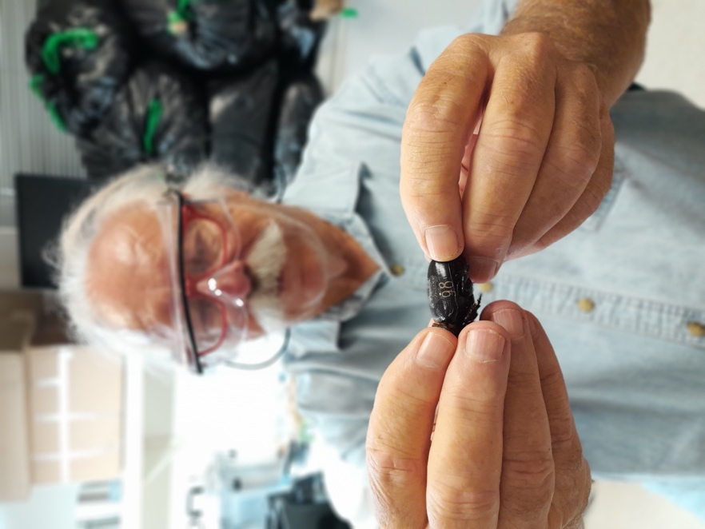

Dr. Aubrey Moore holds a freshly laser-engraved number on a coconut rhinoceros beetle. The engraving allows him to keep data on a large number of beetles’ behavior in the weeks after they’ve been fed a virus. Moore is testing viral infections as a potential biological control for Guam’s invasive rhino beetles.

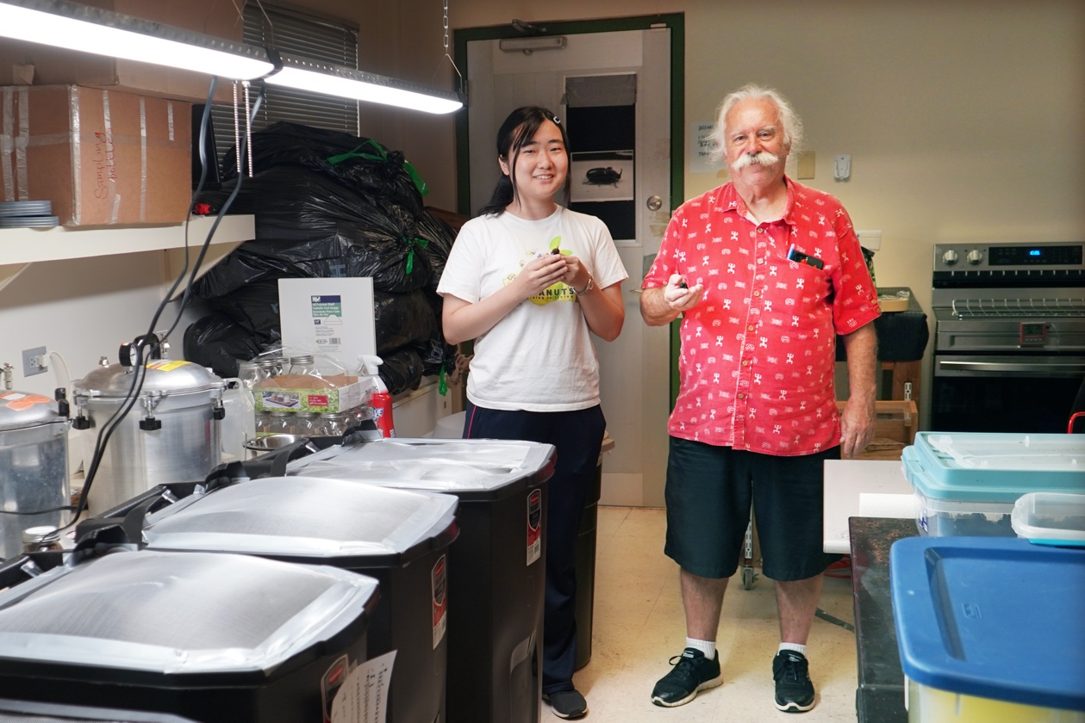

Mayuho Yamauchi, a graduate exchange student from Tokyo University of Agriculture & Technology, and University of Guam entomologist Dr. Aubrey Moore stand by containers they’ve outfitted to test the effect of a virus on rhino beetles’ ability to fly.

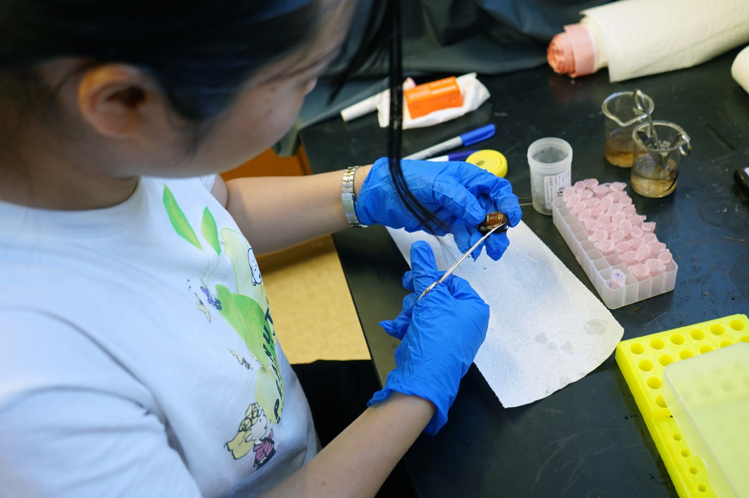

Mayuho Yamauchi, a graduate exchange student from Tokyo University of Agriculture & Technology, dissects a Guam rhino beetle. She is removing the guts of the beetles in her study so she can conduct a lab test back in Tokyo and see if they were successfully infected with a virus that was fed to them.

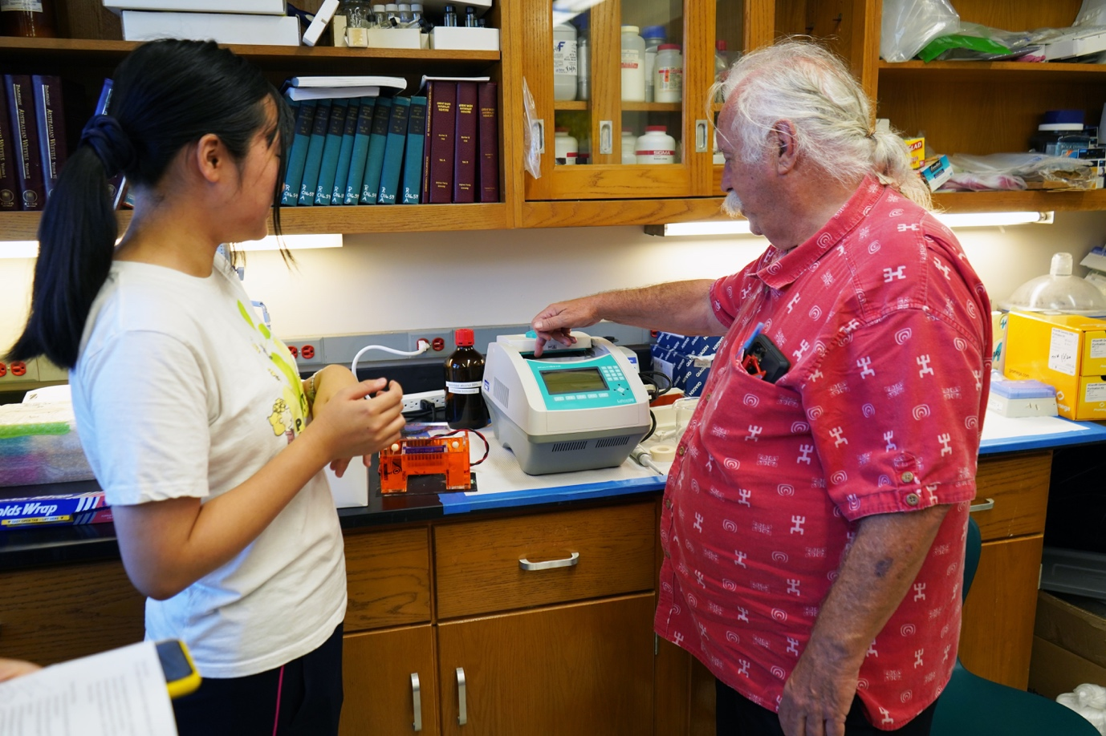

Mayuho Yamauchi, a graduate exchange student from Tokyo University of Agriculture & Technology, and University of Guam entomologist Dr. Aubrey Moore use a spectrophotometer to measure feeding rate of rhino beetles.

**Notes for Jackie – to be deleted at some point**

I deleted this stuff because we haven’t analyzed the data yet.

From their initial data and observations, they didn’t notice any difference in behavior between the groups that were fed the virus and those that weren’t. Moore said his assumption is that Guam’s genotype of CRB is resistant to this particular strain of the virus.

* When will Mayuho have the results from the virus tests?

I need to dissect all the dead beetles and get samples up to Tokyo to test for virus infection. This should be completed during May.

* What will it mean for Guam if the beetles were actually infected? What will it mean if they weren’t?

If the Guam beetles do not get infected by the Palau virus, it probably will not have any lethal or sublethal effects and it certainly will not spread throughout the population or replicate, therefor not a biocontrol agent candidate.

* How many other strains of virus are there that could be tested? Would you use this same experiment each time?

There are a lot of isolates to be tested or retested. Probably about 25 at this point. Most promising after Palau is a new isolate from the Philippines. AgResearch New Zealand will be sending virus samples in about a month from now. They are asking me to use their protocol for initial testing.

* Considering funding and the number of viruses to be tested, how long do you think it might take to find one that works?

This is pure guess work. But I am hoping that my lab or somebody else’s lab will find a good biocontrol candidate for CRB-G before the end of this year.